# Lab 4 - Build your own website

## Getting ready.

1. Extract zip file content (LabFour folder) into your local se-nz-pt-a-4jul22 repository > your own folder.
2. Commit your new files with the message “Lab four setup complete”.
3. Make sure you have installed “Live Server” extension on your VS Code.
4. If you are having any difficulties, contact your trainers by sending slack message or zoom chat.

In this lab you’ll be building the entire website from scratch. You’ll only use very basic HTML boilerplate. Use all the skills that you’ve learned:

* Semantic HTML
* Sections
* Flexbox - layouts, centering elements and spacing elements into opposite corners
* Images and setting-border radius
* 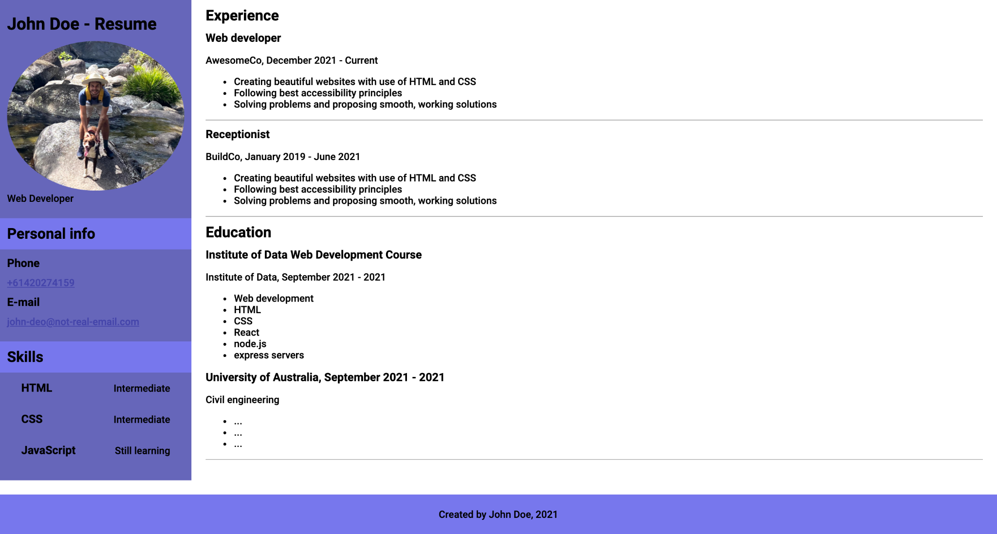Box-model and setting margin, padding, width and height
* Styling text
* Styling links

For example your resume, may look like this:

## Push to git.

1. Commit your work with message “Lab four completed”.
2. Push your work to se-nz-pt-a-4jul22. (don’t forget to pull first)